Module 1 Homework question
The power of brands and ideas

Ideas, ideas, ideas. It is what we are selling (and the brilliant executions of course) But what is an idea? Often, we talk vaguely about them. But what do we mean? There are different types of idea, different levels of idea. Such as the fundamental positioning idea of the brand as well as the creative ideas that we see. So, let’s break it down and analyse the different ideas – it might just give you a way forward.

Here is your task

- Share with me a creative execution (any medium/any type/does not have to be an ad, but can be if you wish) that you think is great and why it is great?

Specifically answer these two questions a) why it is motivating/exciting for its audience(s) and b) why it is effective for the brand that produced it (write no more than 50 words in total)

- Using the iceberg format below work out the different ideas in play in this piece of work (See the notes below to help you do this). Keep it as brief as possible- a short sentence or phrase in each box)

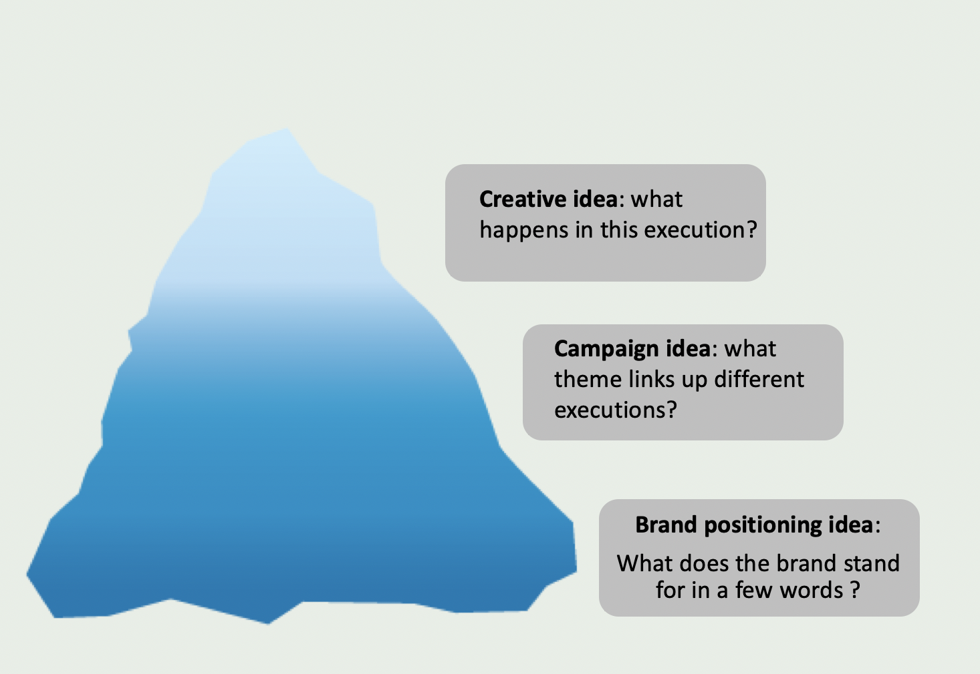

Notes on how to do the iceberg method

Start with the creative idea you have selected

Creative idea (this is about the idea in the execution you have selected)
What happens in the execution?
What is its basic structure?
How does it work as an execution?

Campaign idea (this is about a theme that links up different executions)
What is the theme that links up different executions in the campaign?
What is the idea behind the execution?
(sometimes this is expressed in an end line)

Brand positioning idea (this is about the brand’s fundamental purpose)
What fundamental need (practical or psychological) does this brand satisfy ?
How is this brand positioned in our minds as customers?
Can you sum this up in a short phrase or a few words?
Such as ”Brand xxxxxx is the one that stand for xxxxx

Marking scheme

10 marks for 1

Give me some inspiring work and a short explanation that answers the two questions:- a) why it is motivating/exciting for its audience(s) and b) why it is effective for the brand that produced it (write no more than 50 words In total)

10 marks for 2
Example should clearly be rooted in the brand positioning idea and bring the brand to life in a fresh and interesting way. High marks for coherence- you can see how the top creative idea links down to the bottom brand positioning idea and vice versa

Here are two of the examples talked about
